CARIAD SE CPM Project

Technical Specification

Skip Error Message on Assigning Items

|  |  |
| --- | --- |
| Person Responsible: | Baobao Gao |
| Status: | in review |
| Version: | V1.0 |
| Date: | 16/04/2025 |
|  |  |
|  |  |
|  |  |

Version History:

| Version | Date | Author | Comments |
| --- | --- | --- | --- |
| V1.0 | 16/04/2025 | Baobao Gao |  |
|  |  |  |  |
|  |  |  |  |

# Technical Architecture

# ABAP

## Project Design Brief

Able to assign same portfolio items under multi planning round initiatives.

## Enhancement

* SE20 transaction to view Enhancements.

|  |  |  |
| --- | --- | --- |
| **BADI** | **Enhancement Implementation** | **Short Description** |
| /CPD/BADI_INTRINSIC_STRUCTURES | ZCON_CPMIE_INTRINSIC_STRUCTUR | Additional Object Types ('ZPD') |

* SM30 transaction to maintain table ' ZUTILT_MULTICOMP'

|  |  |  |
| --- | --- | --- |
| Implementation Class | Method | Short Description |
| ZCL_CON_CPM_BADI_INTR_STRUCTUR | /CPD/IF_INTRINSIC_STRUCTURES~FILL_CHILD_TYPES_BY_HEADER | Fill the child types to include in hierarchy |

The configuration is as follows

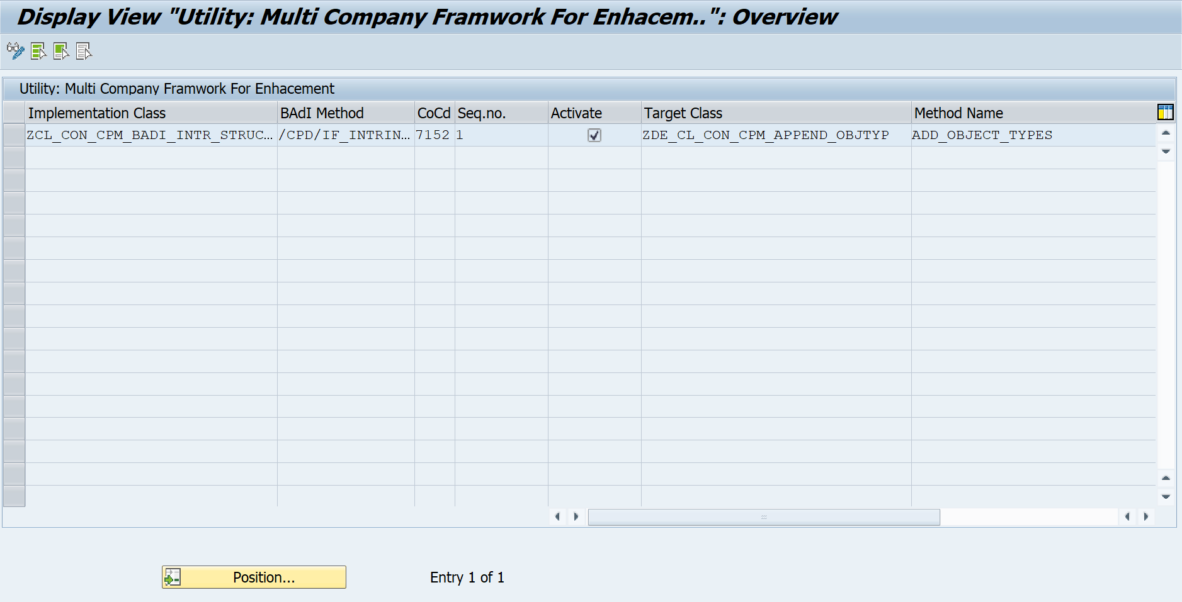

### /CPD/BADI_INTRINSIC_STRUCTURES – Enhancement

* Additional Object Types ('ZPD')

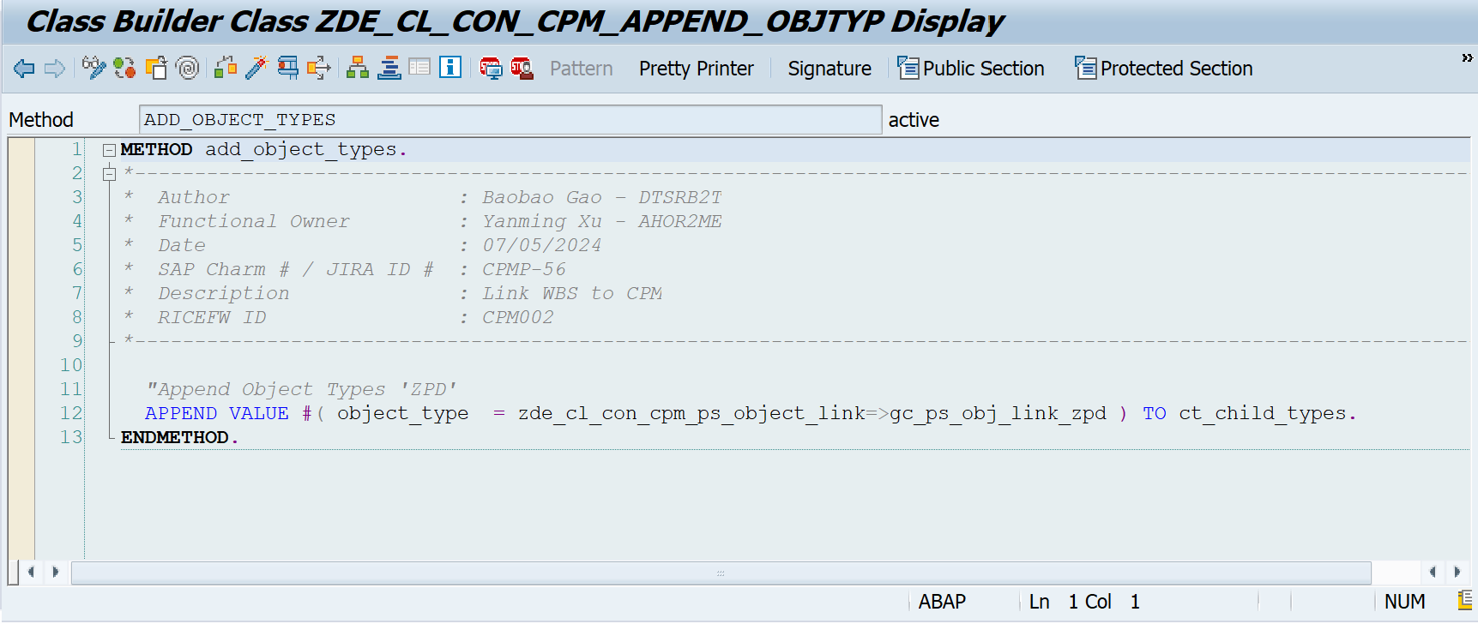

* Filter on retrieving project structure, only display WBS elements which is linked to current CPM master project with object type “0WBS”.

Step1 Copy standard class '/CPD/CL_PS_OBJECT_API ' to ' ZDE_CL_CON_CPM_PS_OBJECT_LINK'

Step2 Method '/CPD/IF_COMMON_ACCESS_API~GET_HIERARCHY' adjustments is as follows:

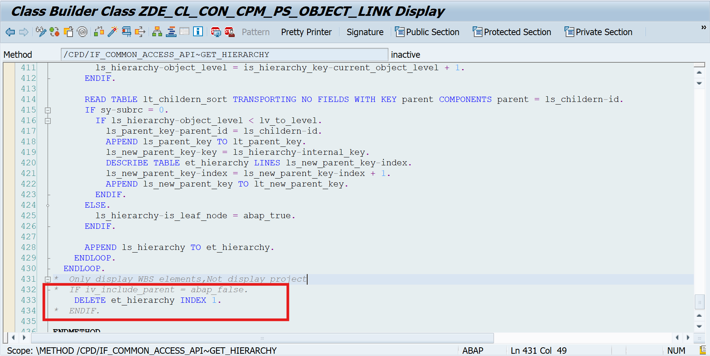

## Authorization

N/A

# Other